Statistika | Srovnání datových souborů | SZŠ a VOŠZ Zlín®
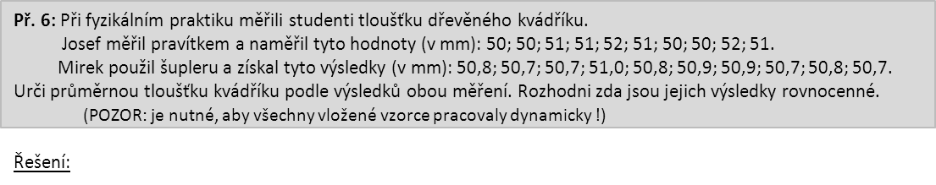
Josef: |  | 50 |  | 50 |  | 51 |  | 51 |  | 52 |  |  |  | Mirek |  | 50,8 |  | 50,7 |  | 50,7 |  | 51 |  | 50,8
 |  | 51 |  | 50 |  | 50 |  | 52 |  | 51 |  |  |  |  |  | 50,9 |  | 50,9 |  | 50,7 |  | 50,8 |  | 50,7

n = R =
x_{i} | 50 |  | 51 |  | 52 |  |  | Σ |  |  |  |  |  |  |  |  |  | x_{i} |  | 50,7 |  |  | 50,8 |  | 50,9 |  |  | 51 | Σ
f_{i} |  |  |  |  |  |  |  |  |  |  |  |  |  |  |  |  |  | f_{i}
f´_{i} |  |  |  |  |  |  |  |  |  |  |  |  |  |  |  |  |  | f´_{i}
x_{i}.f_{i} |  |  |  |  |  |  |  |  |  |  |  |  |  |  |  |  |  | x_{i}.f_{i}
Δ_{i} |  |  |  |  |  |  |  |  |  |  |  |  |  |  |  |  |  | Δ_{i}
f_{i}.Δ_{i} |  |  |  |  |  |  |  |  |  |  |  |  |  |  |  |  |  | f_{i}.Δ_{i}
Δ²_{i} |  |  |  |  |  |  |  |  |  |  |  |  |  |  |  |  |  | Δ²_{i}
f_{i}.Δ²_{i} |  |  |  |  |  |  |  |  |  |  |  |  |  |  |  |  |  | f_{i}.Δ²_{i}
Závěr: |  |  |  |  |  |  |  |  |  |  |  |  |  |  |  |  | Závěr:
x = |  |  |  |  |  |  | σ = |  |  |  |  |  |  |  |  | x = |  |  |  |  |  |  |  |  |  |  | σ =

-----------------------------------------------------------------------------------------------------------------------------------------------------------------------------------

Statistika | Srovnání datových souborů | SZŠ a VOŠZ Zlín®
Josef: |  | 50 |  | 50 |  | 51 |  | 51 |  | 52 |  |  |  | Mirek |  | 50,8 |  | 50,7 |  | 50,7 |  | 51 |  | 50,8
 |  | 51 |  | 50 |  | 50 |  | 52 |  | 51 |  |  |  |  |  | 50,9 |  | 50,9 |  | 50,7 |  | 50,8 |  | 50,7

n = R =

x_{i} | 50 |  | 51 |  | 52 |  |  | Σ |  |  |  |  |  |  |  |  |  | x_{i} |  | 50,7 |  |  | 50,8 |  | 50,9 |  |  | 51 | Σ
f_{i} |  |  |  |  |  |  |  |  |  |  |  |  |  |  |  |  |  | f_{i}
f´_{i} |  |  |  |  |  |  |  |  |  |  |  |  |  |  |  |  |  | f´_{i}
x_{i}.f_{i} |  |  |  |  |  |  |  |  |  |  |  |  |  |  |  |  |  | x_{i}.f_{i}
Δ_{i} |  |  |  |  |  |  |  |  |  |  |  |  |  |  |  |  |  | Δ_{i}
f_{i}.Δ_{i} |  |  |  |  |  |  |  |  |  |  |  |  |  |  |  |  |  | f_{i}.Δ_{i}
Δ²_{i} |  |  |  |  |  |  |  |  |  |  |  |  |  |  |  |  |  | Δ²_{i}
f_{i}.Δ²_{i} |  |  |  |  |  |  |  |  |  |  |  |  |  |  |  |  |  | f_{i}.Δ²_{i}
Závěr: |  |  |  |  |  |  |  |  |  |  |  |  |  |  |  |  | Závěr:
x = |  |  |  |  |  |  | σ = |  |  |  |  |  |  |  |  | x = |  |  |  |  |  |  |  |  |  |  | σ =

